MIS589 Project Proposal  Milestone1 | IT Help Desk  University IT Help Desk
Prepared by :  Date: 09/01/2017 | Approved By:
- Description of the Service- Summary
This project is gone for building up an Online IT Help Desk for the facilities in the university campus. This is an Intranet based application and will run inside the university campus area. This application can be utilized to automate the work process of administration demands for the different facilities in the university. This is one coordinated application that spreads various types of facilities like classrooms, labs, lodgings, mess, container, exercise room, PC labs, and teachers club and so on. Registered clients (understudies, teachers, lab-technician and others) will have the capacity to sign in a demand for benefit for any of the upheld facilities. These solicitations will be sent to the concerned individuals, who are additionally valid clients of the university system, to get them settled. There are highlights like email updates, expansion of another facility to the framework, report generators and so forth.
2. Intended clients or customers
There are three kinds of users for this system:
- Those who use the system to create a request called as end-users normally they will be students.
- Those who look at the created requests and assign them to the concerned people called the facility-heads here they will be university directors.
- Those who work on the assigned requests and update the status of the same on the system called the assignees in university an assignees may be any lab technician.
One more type of user of this project is Administrator who is responsible for creating user accounts, adding new facilities to the system etc.
3. Business Objective Statement
By using the Online IT Help Desk System the campus achieve 100% response time rate and provide better solution of any problem related inside campus problems, with a brand making concept university campus get the cutting edge advantages.
4. Application Architecture Description
The helpdesk application itself won't manage the security viewpoints – Active Directory will deal with this. The arrangement will utilize the current SQL Server and will use email offices gave by the Exchange server. At last, the customer speaks with only one server, which unites every level in a solitary purpose of passage for the customer and references different levels when they are required.
Customer
Helpdesk
Support call
Calls
Logs
Diverse clients of the framework have the distinctive exercises these exercises can be seen through UML charts that demonstrates the application design of the IT Help framework.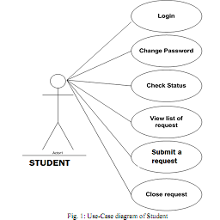 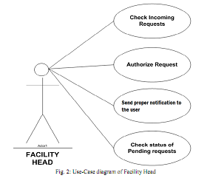

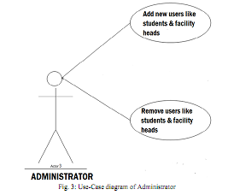
5. Information provided to the clients
Here the all three types of client or user can get the following three types of information:
- A new admitted student who is having some problem can log in to system and can notice what are the other section/categories of the campus from where in future he may have any problem. So the new user learns the different aspect of the university campus through this application.
After submitting his personal information and problem the student gets the token no. Against which he can track his problem in future. Student will get feedback against the token no when the problem is resolved.
- The director (facility head) of university gets the information about the student problem and sends it to the concern technician or person (assignees) who can resolve it easily. Director get the student name and token no and a detailed description of the problem that is written by the student. Director of university not only solve any particular problem but also notice the area from where the maximum no. of problems are raising. Facility head will also get feedback against the token no when the problem is resolved.
- Assignees get the information about the problem, where it is start , who is effected, How to resolve? Assignees get the information about the token generated student and facility head’s suggestion. When the problem is resolve completely Assignees will send an acknowledgement to the student & director (facility head) of university against the same token number.
6. Basic Requirements
For advancement of the application we require a framework with great setup. A framework with quick handling velocity and enough memory is required.
Hardware requirements
Number | Description | Alternatives (If available)
1 | PC with 2 GB hard-disk and 256 MB RAM | Not-Applicable
Software requirements
Number | Description | Alternatives (If available)
1 | Windows 95/98/XP with MS-office | Not Applicable
2 | MS-SQL server | MS-Access
Manpower requirements
2 to 3 software developers can develop this application in 4 – 6 months.
Conclusion
The present administrations of a campus, for example, asking for archives, endorsements, authorizations and so forth are satisfied manually which takes a considerable measure of time. The point of our undertaking is to build up an online IT help desk for the facilities accessible in the University campus. This is a web application that can be gotten to all through the University campus. Our application can be utilized to computerize the work stream of administration demands for the different facilities accessible in the University. This online IT Help Desk application is the little stride to diminish the correspondence distance between the staffs and the understudies. In future this small project may be useful to find the different kind of information such as No. of problem resolved per period, No. of problem resolved first call, No. of problem resolved by any particular person, Average time for initial response and Average time to resolution etc. This important information may give other business objective solution on time.

